Fixed-wing Lesson 3 Longitudinal Model

[1. Lesson Introduction](https://classroom.udacity.com/nanodegrees/nd787/parts/ee7d5970-d39c-4355-952e-ce760e701827/modules/2dd61f74-6310-4f18-98b2-e4a9a9450f85/lessons/0a30baf0-ff83-495e-9a19-2a626751d41c/concepts/1c413492-c830-4c58-bb4b-0c8c1e8ec530)

<https://www.youtube.com/watch?time_continue=2&v=1-iv2ZHEGDg>

[2. Force-Free Motion](https://classroom.udacity.com/nanodegrees/nd787/parts/ee7d5970-d39c-4355-952e-ce760e701827/modules/2dd61f74-6310-4f18-98b2-e4a9a9450f85/lessons/0a30baf0-ff83-495e-9a19-2a626751d41c/concepts/748c7d41-cbad-408c-b517-41d043b3a377)

<https://www.youtube.com/watch?v=UBWxJ6Cub6U>

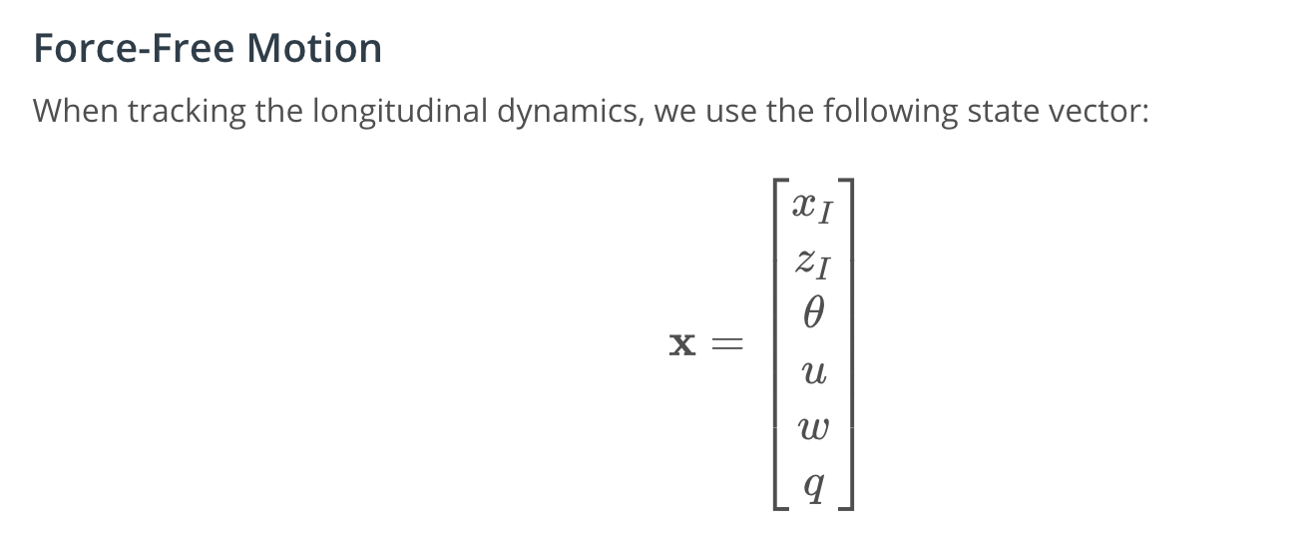

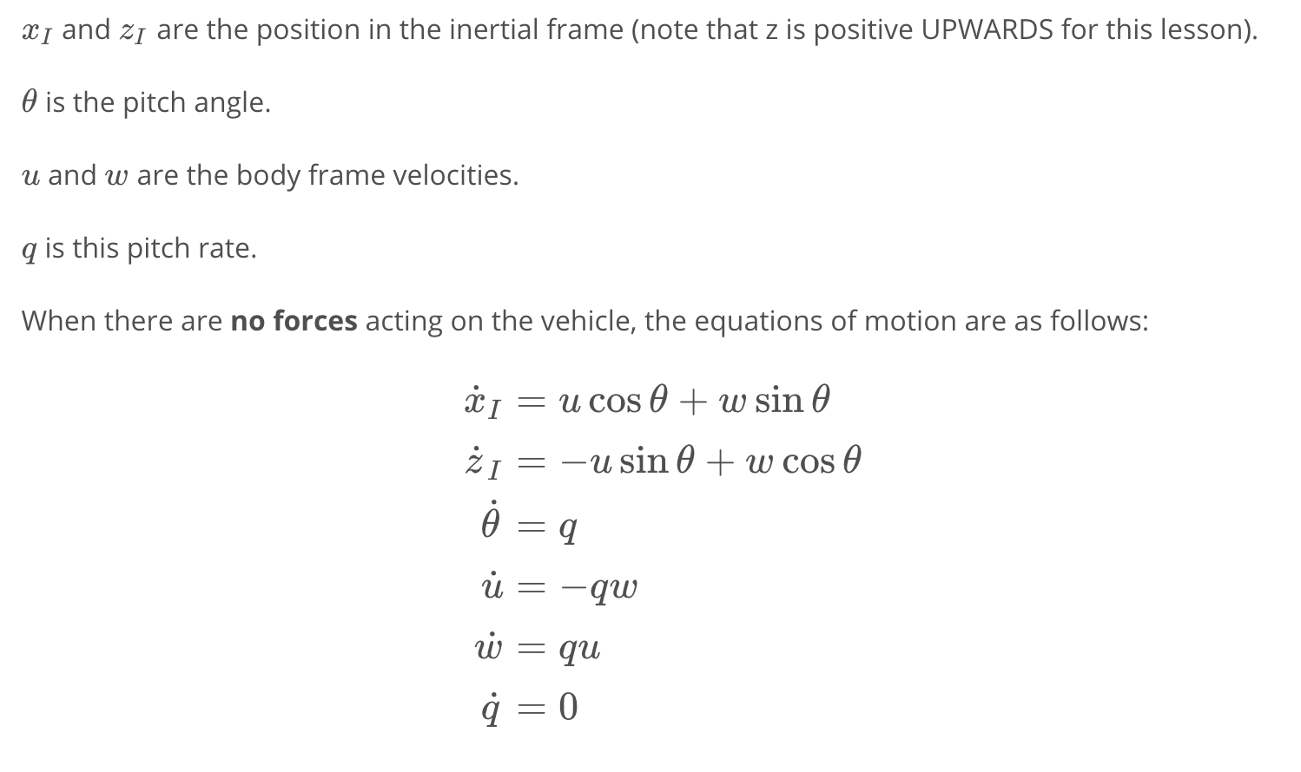

### **Reminder: Fixed Wing Cheat Sheet**

You can find all of the equations for this module in the [Fixed Wing Cheat Sheet](https://www.overleaf.com/read/cvqmtzyhqjnj).

[3. Quiz: Characterizing State Variables](https://classroom.udacity.com/nanodegrees/nd787/parts/ee7d5970-d39c-4355-952e-ce760e701827/modules/2dd61f74-6310-4f18-98b2-e4a9a9450f85/lessons/0a30baf0-ff83-495e-9a19-2a626751d41c/concepts/cd0b74f4-d7f0-4d0d-9ce5-8064d0865e7a)

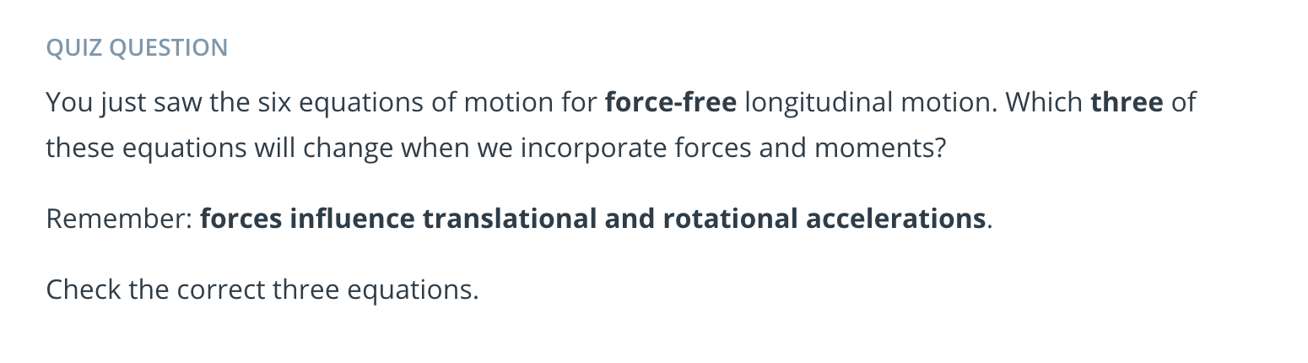





[4. Full Longitudinal Dynamics](https://classroom.udacity.com/nanodegrees/nd787/parts/ee7d5970-d39c-4355-952e-ce760e701827/modules/2dd61f74-6310-4f18-98b2-e4a9a9450f85/lessons/0a30baf0-ff83-495e-9a19-2a626751d41c/concepts/394397da-2e78-4ebb-8b6d-f6a19a5c3c4d)

<https://www.youtube.com/watch?v=FZMja7L7hn4>

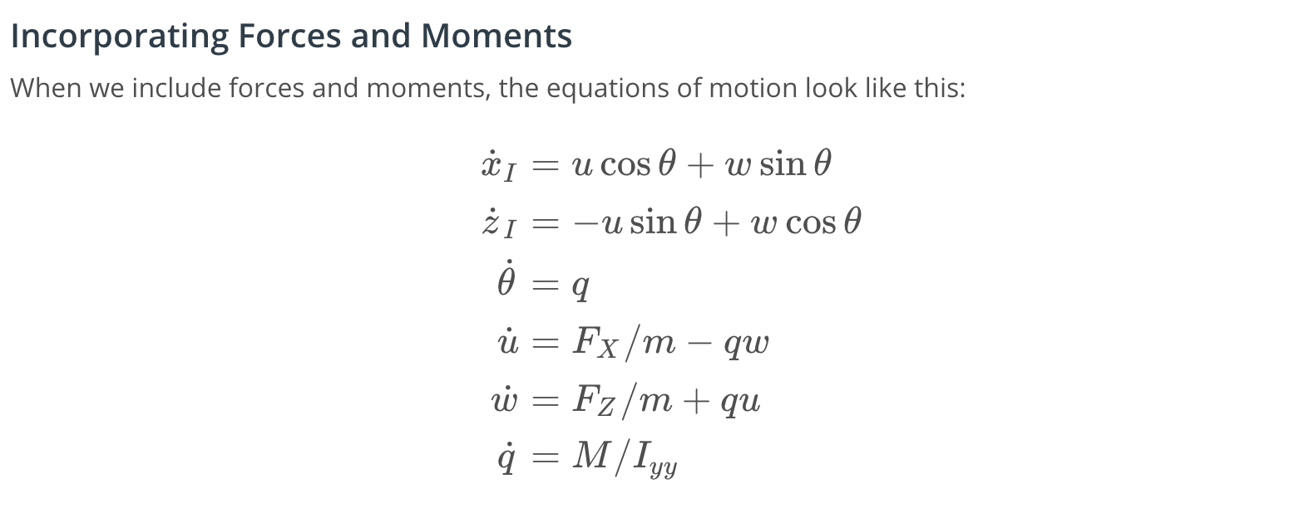

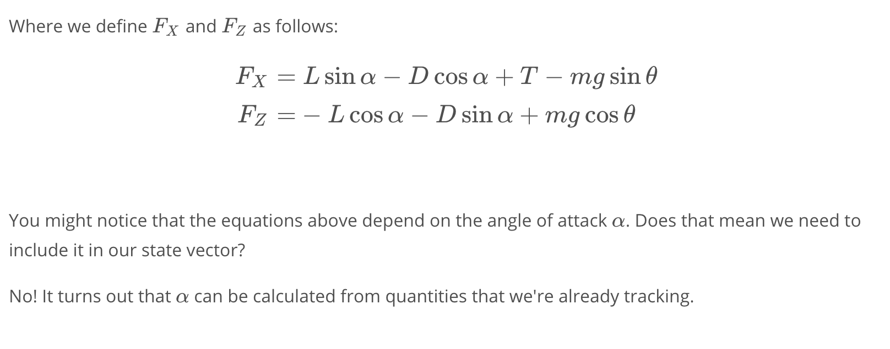

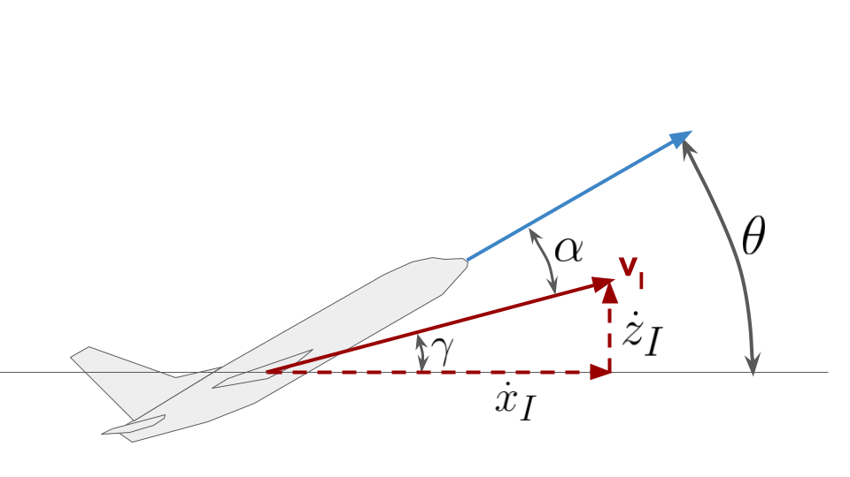

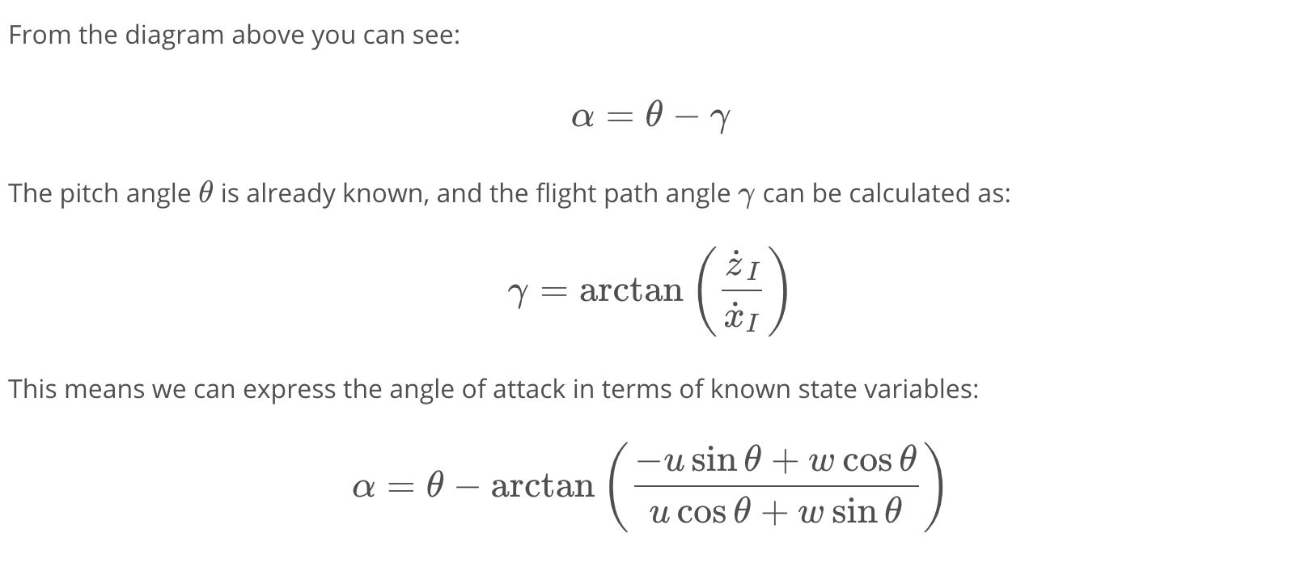

[5. Exploring Longitudinal Dynamics Exercise](https://classroom.udacity.com/nanodegrees/nd787/parts/ee7d5970-d39c-4355-952e-ce760e701827/modules/2dd61f74-6310-4f18-98b2-e4a9a9450f85/lessons/0a30baf0-ff83-495e-9a19-2a626751d41c/concepts/13339ec4-32c5-4bc2-b948-274e7518eaa1)

# **Exploring Longitudinal Dynamics**

In this exercise (Longitudinal model-Student.ipynb), you will have the chance to implement the longitudinal equations of motion and then use those equations to simulate the longitudinal flight of an aircraft.

If you aren't interested in implementing these equations yourself, you should at least go through the solution (Longitudinal model-Solution.ipynb) we've provided so that you can see plots of some unexpected longitudinal trajectories.

[Longitudinal model-Student.ipynb](https://viewhye61afzq7.udacity-student-workspaces.com/notebooks/Longitudinal%20model-Student.ipynb)

[6. Understanding Oscillations](https://classroom.udacity.com/nanodegrees/nd787/parts/ee7d5970-d39c-4355-952e-ce760e701827/modules/2dd61f74-6310-4f18-98b2-e4a9a9450f85/lessons/0a30baf0-ff83-495e-9a19-2a626751d41c/concepts/8db4d6cf-e2d5-4864-be52-781562352307)

<https://www.youtube.com/watch?v=GYaU98xGq5w>

[7. The Rest of the Lesson](https://classroom.udacity.com/nanodegrees/nd787/parts/ee7d5970-d39c-4355-952e-ce760e701827/modules/2dd61f74-6310-4f18-98b2-e4a9a9450f85/lessons/0a30baf0-ff83-495e-9a19-2a626751d41c/concepts/12cb0ce3-720a-402c-9a5a-24eef01bad18)

<https://www.youtube.com/watch?v=IAlM_7JrOBY>

[8. Linearized Model](https://classroom.udacity.com/nanodegrees/nd787/parts/ee7d5970-d39c-4355-952e-ce760e701827/modules/2dd61f74-6310-4f18-98b2-e4a9a9450f85/lessons/0a30baf0-ff83-495e-9a19-2a626751d41c/concepts/081d2dbe-13f6-42e4-a6ac-c2893918e612)

<https://www.youtube.com/watch?v=OHJL7tIpKEw>

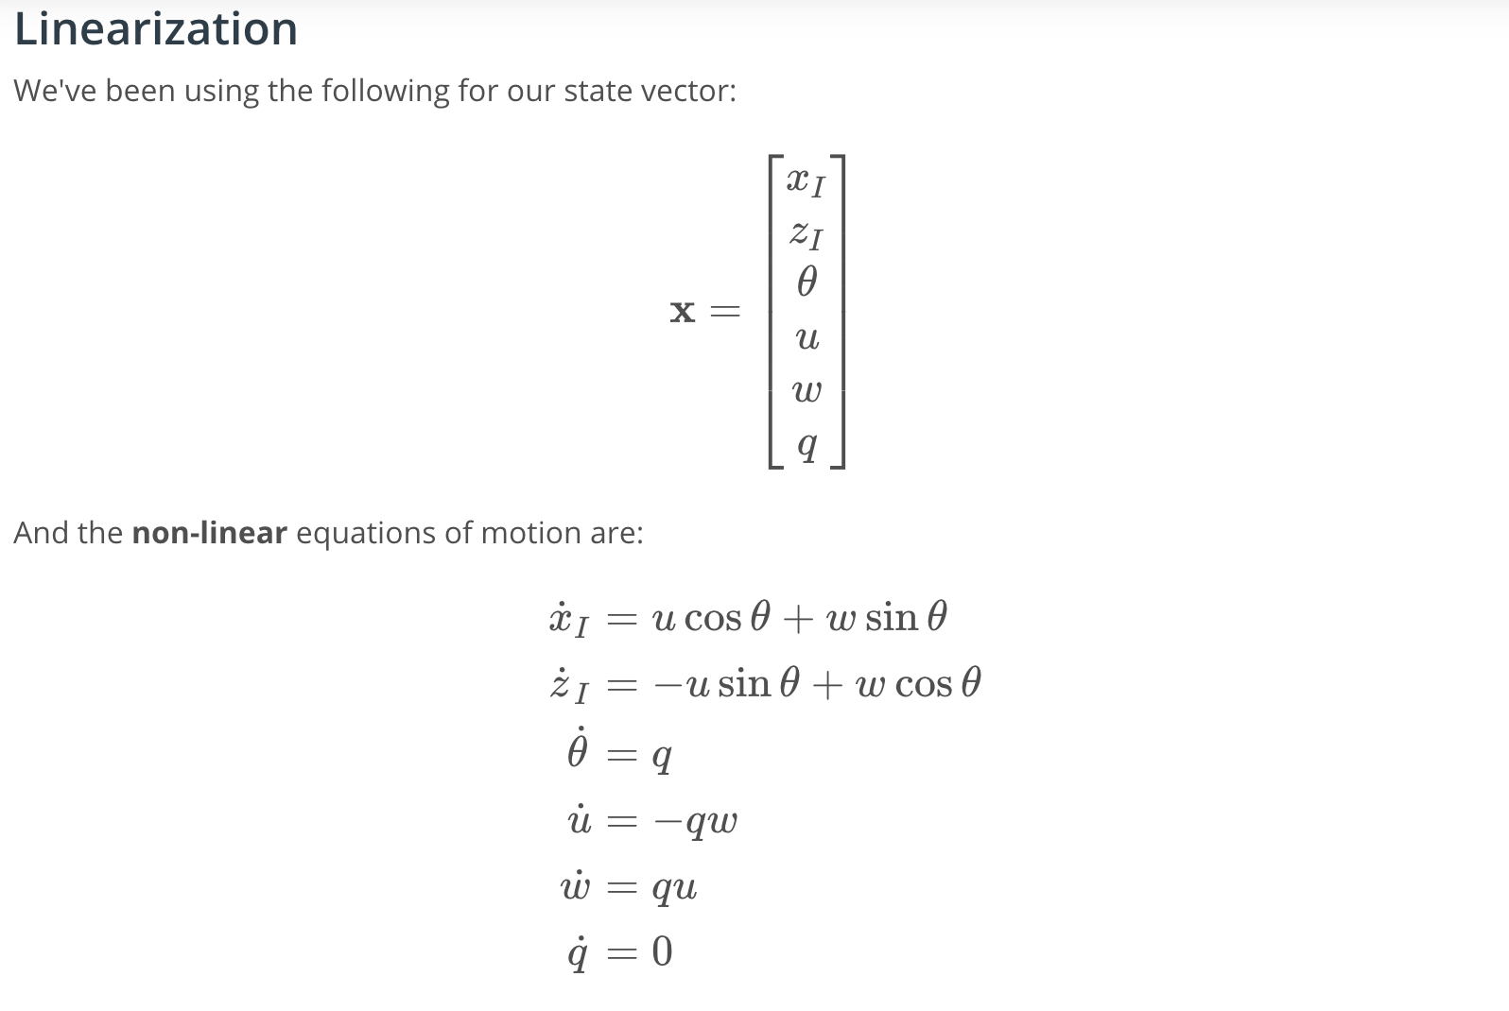

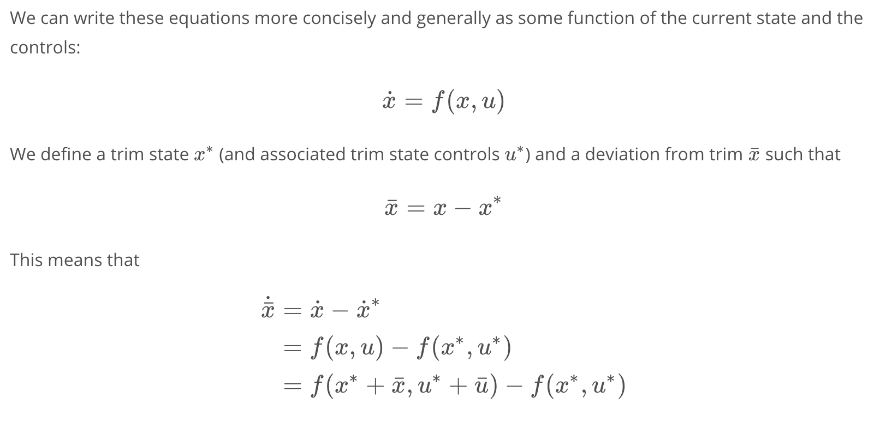

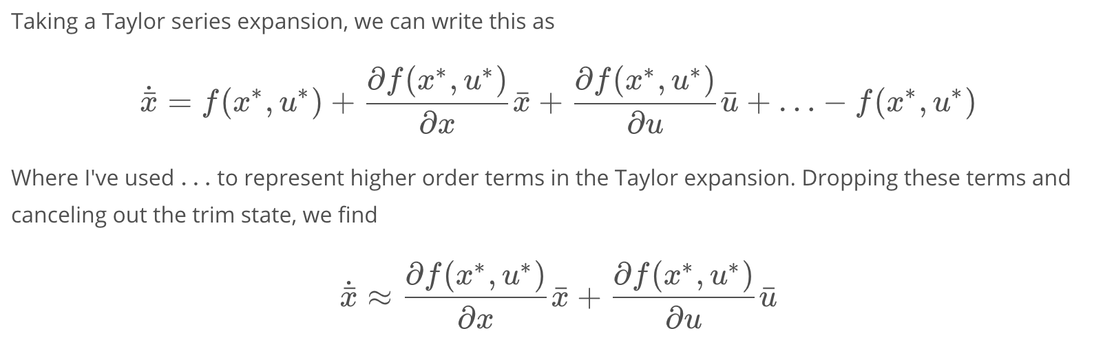

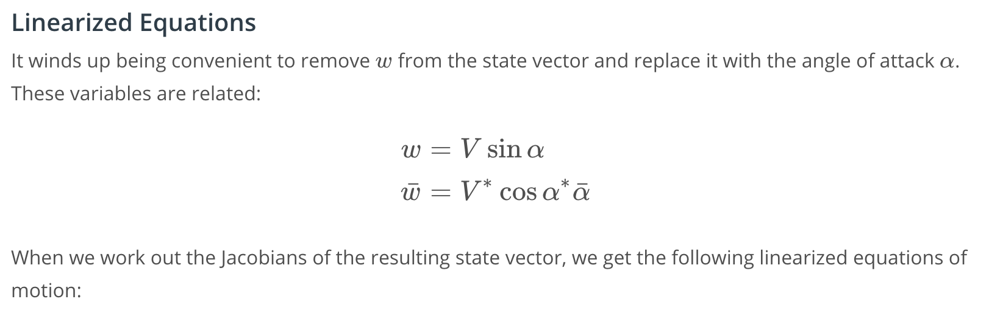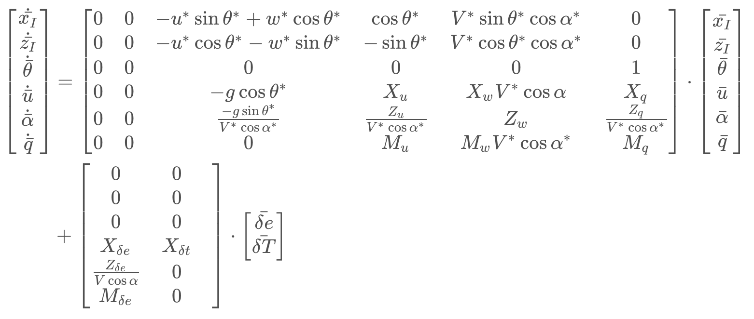

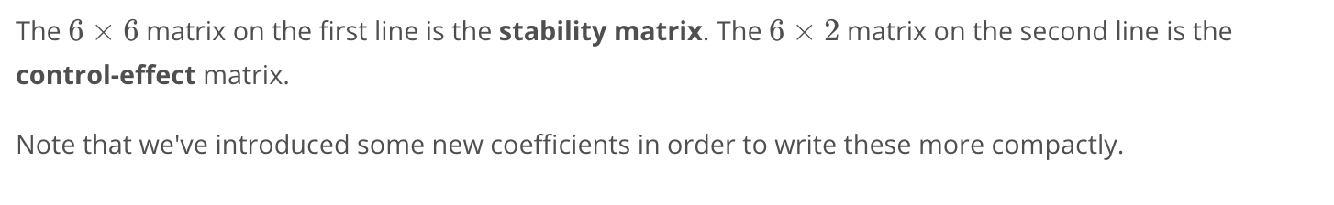

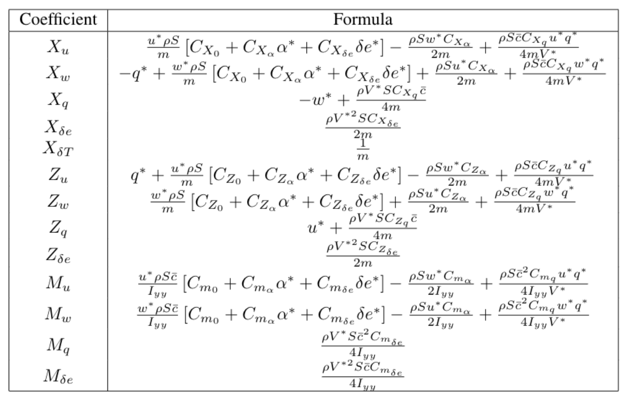

Remember: you can find all of these equations in the [fixed wing cheat sheet](https://www.overleaf.com/read/cvqmtzyhqjnj).

[9. Eigenvalues and Eigenvectors](https://classroom.udacity.com/nanodegrees/nd787/parts/ee7d5970-d39c-4355-952e-ce760e701827/modules/2dd61f74-6310-4f18-98b2-e4a9a9450f85/lessons/0a30baf0-ff83-495e-9a19-2a626751d41c/concepts/92ca68b7-bc41-4a37-8342-38c78d87152d)

<https://www.youtube.com/watch?v=ZehfPpMlyUc>

[10. Exploring Complex Exponentials Notebook](https://classroom.udacity.com/nanodegrees/nd787/parts/ee7d5970-d39c-4355-952e-ce760e701827/modules/2dd61f74-6310-4f18-98b2-e4a9a9450f85/lessons/0a30baf0-ff83-495e-9a19-2a626751d41c/concepts/f0421f11-85df-4740-8176-342069418023)

[complex_exponentials.ipynb](https://view40bac7dd.udacity-student-workspaces.com/notebooks/complex_exponentials.ipynb)

[11. Exponentials and Stability](https://classroom.udacity.com/nanodegrees/nd787/parts/ee7d5970-d39c-4355-952e-ce760e701827/modules/2dd61f74-6310-4f18-98b2-e4a9a9450f85/lessons/0a30baf0-ff83-495e-9a19-2a626751d41c/concepts/4aa9048a-4e9b-459f-9fe8-125bf4ff3076)



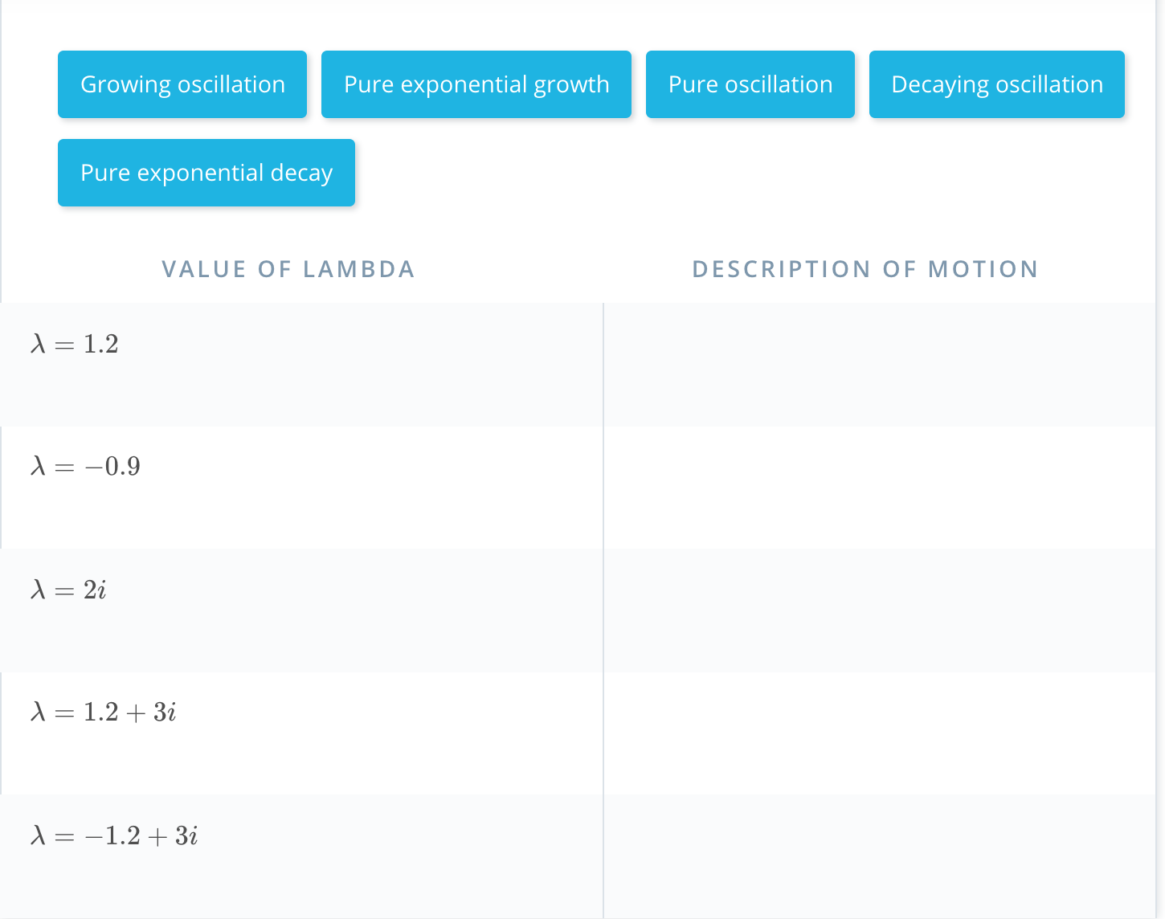

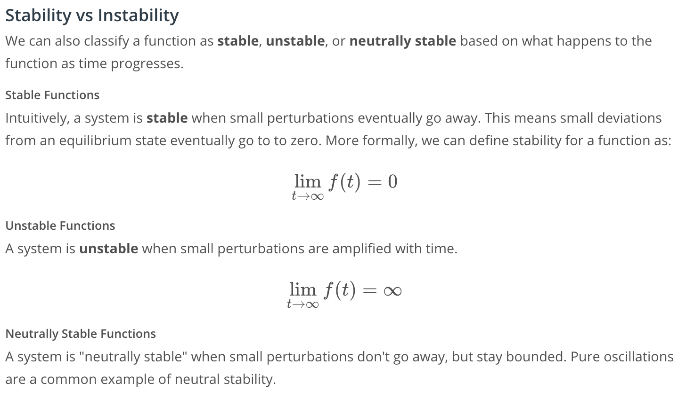

### **Relationship to Complex Exponentials**

The **real** part of a complex exponential dictates the stability of the system. When the real part is positive, the system is unstable. When the real part is negative, the system is stable.

[12. Modes of Motion](https://classroom.udacity.com/nanodegrees/nd787/parts/ee7d5970-d39c-4355-952e-ce760e701827/modules/2dd61f74-6310-4f18-98b2-e4a9a9450f85/lessons/0a30baf0-ff83-495e-9a19-2a626751d41c/concepts/221b1431-fbb5-42fc-bb57-382d8d46c8b7)

<https://www.youtube.com/watch?v=wsTmXnLt_Fs>

[13. Identifying Eigenvalues Exercise](https://classroom.udacity.com/nanodegrees/nd787/parts/ee7d5970-d39c-4355-952e-ce760e701827/modules/2dd61f74-6310-4f18-98b2-e4a9a9450f85/lessons/0a30baf0-ff83-495e-9a19-2a626751d41c/concepts/cf3c6ae6-ff1b-4f73-b82c-c014c9a2414f)

# **Identifying Eigenvalues**

In this exercise you will have the chance to work with a partially-implemented linearized longitudinal model.

You have the option of completing this exercise yourself (Linear Model with Phugoidal modes-Student.ipynb) or reading/working through the solution (Linear Model with Phugoidal modes-Solution.ipynb)

[Linear Model with Phugoidal modes-Student.ipynb](https://viewb1xd93mzxx.udacity-student-workspaces.com/notebooks/Linear%20Model%20with%20Phugoidal%20modes-Student.ipynb)

[14. Short Period Response and Phugoid](https://classroom.udacity.com/nanodegrees/nd787/parts/ee7d5970-d39c-4355-952e-ce760e701827/modules/2dd61f74-6310-4f18-98b2-e4a9a9450f85/lessons/0a30baf0-ff83-495e-9a19-2a626751d41c/concepts/67d46b2d-31c3-4ac0-98eb-b82a9aa42a3d)

<https://www.youtube.com/watch?v=yJ6XJNYhHWw>

[15. Conclusion](https://classroom.udacity.com/nanodegrees/nd787/parts/ee7d5970-d39c-4355-952e-ce760e701827/modules/2dd61f74-6310-4f18-98b2-e4a9a9450f85/lessons/0a30baf0-ff83-495e-9a19-2a626751d41c/concepts/1574afb3-de15-4640-858b-7e3146f2efa6)

<https://www.youtube.com/watch?v=8kQI5lI_aIo>